Home Planning – Layout – 2021/08/27

# This document contains private information regarding the development plans of the employer- Keson Dutta. No data is supposed to be leaked out of the site during the entire process as it may lead to future disrupts and cause harm for the residents of the house.

## Please note that all of this is to ensure the safety of the people. In case this request is violated, penalty and actions are supposed to be taken accordingly.

**Home views:**

**Top**

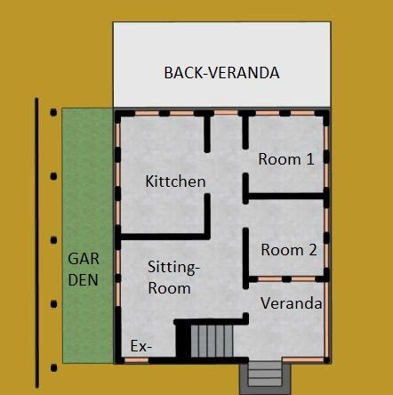

Page- 1

**SIDE VIEWS:**

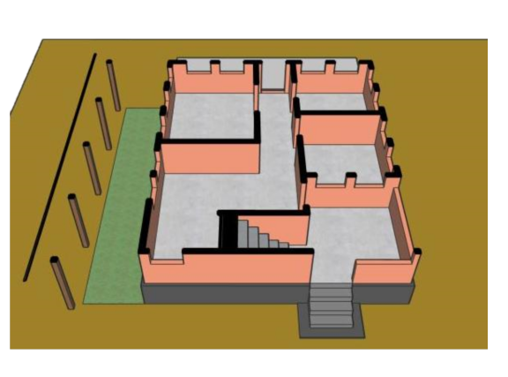

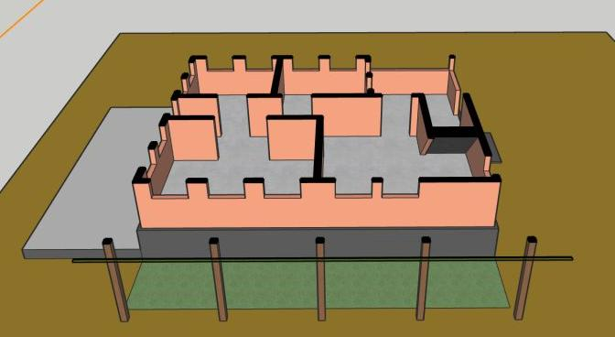

Page- 3

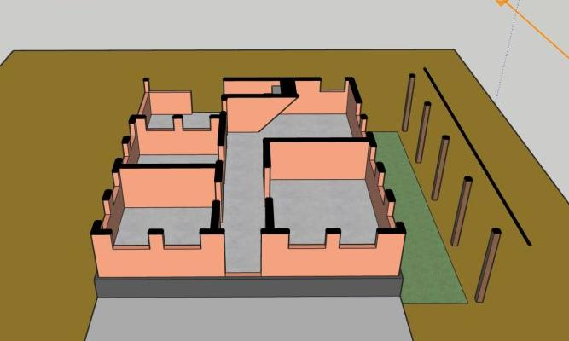

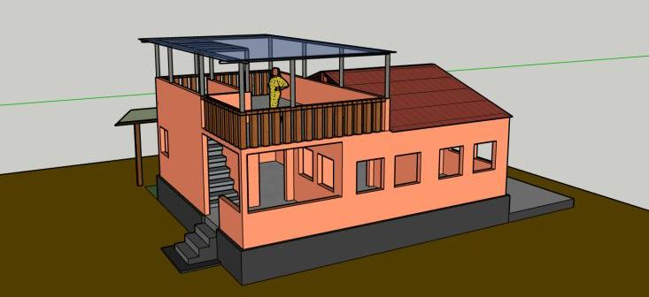

Page- 3

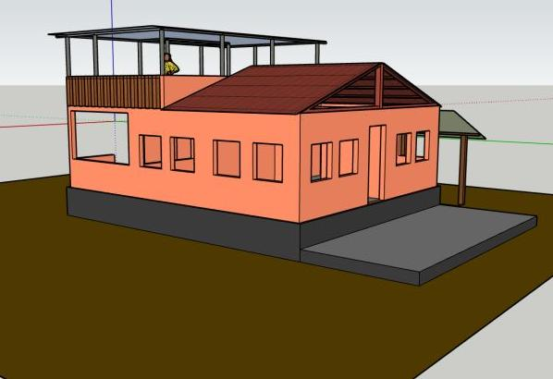

Page- 4